**Mail Merge – Step by Step**

Mail Merge is a function of Microsoft - Word often used to print or email form letters to multiple recipients. Using Mail Merge, we can easily customize form letters for individual recipients. Mail merge is also used to create envelopes or labels in bulk.

This feature works the same in all modern versions of Microsoft Word like: 2007, 2013, and 2016 etc.

1. In a blank Microsoft Word document, click on the Mailings tab, and in the Start Mail Merge group, click Start Mail Merge.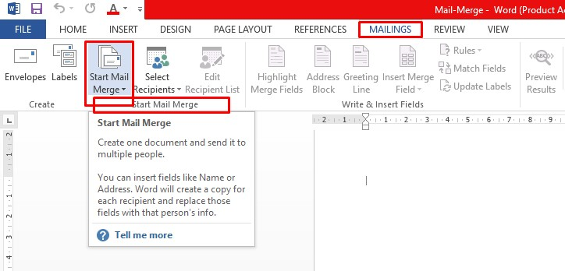
2. 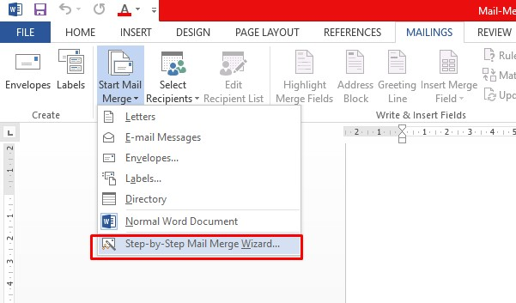Click Step-by-Step Mail Merge Wizard.

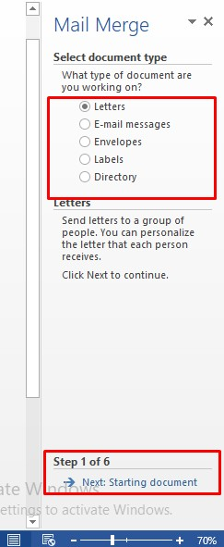

1. Select your document type. In this demo we will select Letters. Click Next: Starting document.
2. Select the starting document. In this demo we will use the current (blank) document. Select Use the current document and then click Next: Select recipients.

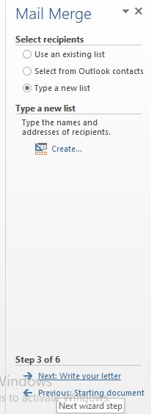

1. 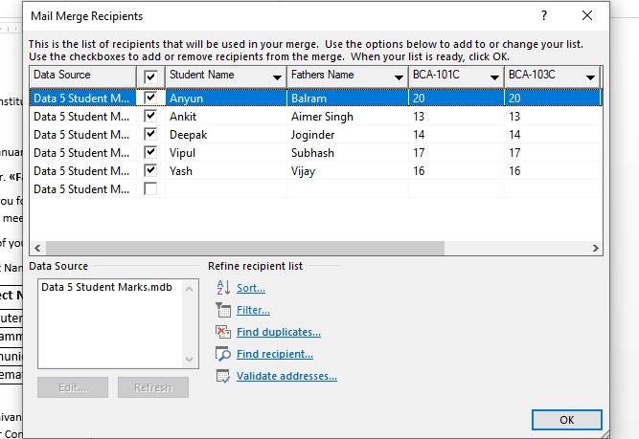Select recipients. In this demo we will create a new list, so select Type a new list and then click Create. 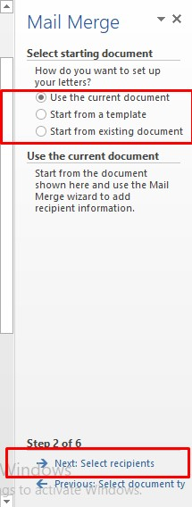
2. 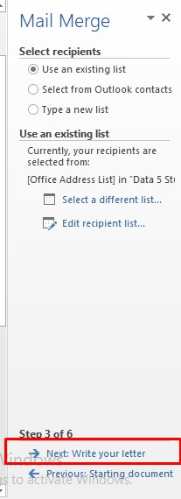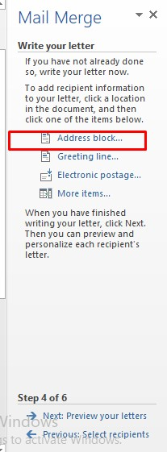Click Next: Write your letter.
3. 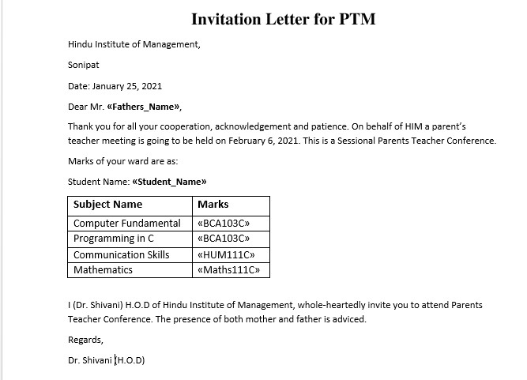Write the letter and add custom fields.
4. Press Enter on your keyboard and click Greeting line... to enter a greeting. 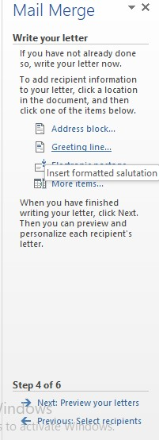
5. 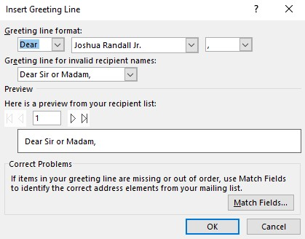In the Insert Greeting Line dialog box, choose the greeting line format by clicking the drop-down arrows and selecting the options of your choice, and then click OK.
6. Note that the address block and greeting line are surrounded by chevrons (« »). Write a short letter and click Next: Preview your letters.